UIUNest
Smart Housing & Marketplace Portal for UIU Students
────────────────────────────────────────────────────────────
Department: Computer Science and Engineering
Course: Database Management Systems Laboratory
Course Code: CSE 3522 / CSI 222
Report Type: Final Project Report
Submission: June 2026
United International University (UIU)

Team Members
No. | Full Name | Student ID
1 | Sadia Noman Tonni | 0112420097
2 | Ahmad Maruf Hossain | 0112420505
3 | Mohammad Mahadi Hasan | 0112420506
4 | Khandaker Tanver Ahmed | 0112410283
5 | Arafat Khan | 0112320272

Table of Contents
1. Introduction / Overview 5
2. Motivation 6
The Hidden Costs Problem 6
The Compatibility Problem 6
The Trust Problem 6
The Community Goods Problem 6
3. Similar Projects 7
CareTutors (caretutors.com) 7
Bproperty (bproperty.com) 7
Bikroy.com 7
Facebook Groups 7
SpareRoom (UK) 7
4. Benchmark Analysis 8
5. Complete Feature List 9
5.1 User Account Management 9
5.2 Property Listing System 9
5.3 Property Search and Discovery 9
5.4 Flatmate Compatibility Matching 9
5.5 Seeking Posts Board 10
5.6 Multi-Dimensional Review System 10
5.7 Complaint and Moderation System 10
5.8 Landlord Verification System 10
5.9 Rent History Tracker 10
5.10 Mess Bill Management Module 10
5.11 UIUNest Exchange — Community Marketplace 11
5.12 Admin Dashboard and Analytics 11
5.13 Notification System 11
5.14 Application System 11
6. Technology Stack 12
File Structure 12
7. Database Design Approach 14
Entity Groups 14
8. Entity-Relationship Diagram (ERD) 15
9. Database Schema — All 19 Tables 16
Table 1: users 16
Table 2: zones 16
Table 3: listings 16
Table 4: utility_costs 17
Table 5: listing_amenities 17
Table 6: user_preferences 17
Table 7: reviews 17
Table 8: complaints 18
Table 9: seeking_posts 18
Table 10: monthly_bills 18
Table 11: bill_payments 19
Table 12: rent_history 19
Table 13: items (UIUNest Exchange) 19
Table 14: offers 19
Table 15: applications 20
Table 16: verifications 20
Table 17: watchlists 20
Table 18: seeking_responses 20
Table 19: notifications 21
10. Key SQL Queries 22
10.1 SELECT with Multi-Table JOIN 22
10.2 SELECT with Aggregate Functions 22
10.3 SELECT with Subquery 23
10.4 INSERT Operations 23
10.5 UPDATE Operations 23
10.6 DELETE Operations 24
10.7 Notifications Query (User-Specific) 24
11. Application Screenshots 25
12. User Roles & Access Control 28
13. System Architecture 29
Presentation Layer (Frontend) 29
Application Layer (PHP API) 29
Data Layer (MySQL) 29
Request Flow Example: Submitting an Offer 29
14. Limitations 30
15. Future Work 31
16. Conclusion 32

1. Introduction / Overview
UIUNest is a fully functional, database-driven web application designed exclusively for the students and faculty of United International University (UIU) and the surrounding campus community. The platform serves as a structured ecosystem connecting three types of users - Students, Landlords, and Administrators - through an integrated housing and marketplace system.
The application addresses a core problem that every UIU student living away from home has personally encountered: finding a room or mess near campus currently requires physically walking through surrounding areas, relying on word-of-mouth, or posting on informal Facebook groups where information is unverified, unstructured, and unreliable.
UIUNest replaces this fragmented process with a single platform built around five major components:
• Property listings with full cost transparency and structured cost breakdowns
• Flatmate compatibility matching based on user preference profiles
• A "Seeking" board where students post housing requirements
• A multi-dimensional review and complaint system for trust and accountability
• UIUNest Exchange - an integrated student-to-student marketplace for second-hand household items
The project demonstrates advanced relational database concepts including multi-table JOINs, aggregate functions, subqueries, transactional INSERT/UPDATE/DELETE operations, and enforced referential integrity via foreign key constraints - making it an ideal vehicle for a Database Management Systems laboratory course.

2. Motivation
The motivation for UIUNest is rooted in problems the team has experienced firsthand as UIU students. Four distinct real-world problems were identified:

The Hidden Costs Problem
A landlord near UIU may advertise a room for 3,500 BDT per month. What they do not disclose is the electricity bill on a shared sub-meter, gas bill, building maintenance, caretaker fee, and three months' advance deposit. UIUNest solves this by requiring landlords to complete a structured cost breakdown form. Every charge is stored as a separate database field and displayed transparently, with the total true monthly cost computed automatically.

The Compatibility Problem
Shared messes require social compatibility beyond rent. A student who studies until 2am cannot comfortably share a room with someone who sleeps at 10pm. Dietary preferences, guest policies, and cleanliness standards are never discussed through a Facebook post. UIUNest introduces a housing preference profile for every user and computes a compatibility score by comparing preference tables via SQL JOINs.

The Trust Problem
Student housing in Bangladesh has a well-known trust deficit. Landlords misrepresent properties, charge undisclosed fees, or refuse to return security deposits. UIUNest addresses this through a multi-dimensional review system, a formal complaint mechanism with admin oversight, and a landlord verification badge requiring document submission.

The Community Goods Problem
UIU students accumulate household items - fans, study tables, chairs, mattresses, mini-fridges. UIUNest Exchange is an integrated student-to-student marketplace. Because all users are already in a campus housing context, buyers and sellers are geographically close by default, and a structured offer-and-counteroffer system removes the awkwardness of open price negotiation.

3. Similar Projects
Several existing platforms share partial features with UIUNest, but none were designed for student housing at UIU or in Bangladesh, and none integrate housing search, cost transparency, flatmate compatibility, and a linked marketplace.

CareTutors (caretutors.com)
Primary architectural inspiration - a Bangladesh-based two-sided marketplace where one party creates a structured profile and the other searches and filters to find a match. UIUNest mirrors this approach and extends it with a marketplace layer.

Bproperty (bproperty.com)
Bangladesh's largest real estate platform. Target market is professionals and families. Does not support mess listings, shared rooms, student-specific cost transparency, or flatmate matching.

Bikroy.com
Bangladesh's largest classifieds platform. Rental and second-hand goods sections function as raw, unstructured bulletin boards with no verification, standardized pricing, or compatibility features.

Facebook Groups
Large portion of UIU student housing activity. No database structure - posts are unformatted, unverifiable, and quickly buried. UIUNest is the structured, persistent, searchable replacement.

SpareRoom (UK)
Technical reference for compatibility matching and review system. Operates in a different market and does not address cost transparency or Bangladesh-specific needs.

4. Benchmark Analysis
● = Full support ◑ = Partial support ○ = Absent

Feature | UIUNest | Bproperty | Bikroy | Facebook | SpareRoom
Student-focused housing | ● | ○ | ◑ | ◑ | ◑
Mess / shared room support | ● | ○ | ○ | ◑ | ●
Itemized cost transparency | ● | ○ | ○ | ○ | ○
Flatmate compatibility score | ● | ○ | ○ | ○ | ◑
Verified landlord badge | ● | ◑ | ○ | ○ | ◑
Multi-dimensional reviews | ● | ◑ | ○ | ○ | ◑
Seeking / looking-for posts | ● | ○ | ○ | ● | ●
Live interactive map | ● | ● | ○ | ○ | ◑
Rent history tracker | ● | ○ | ○ | ○ | ○
Complaint mechanism | ● | ○ | ○ | ○ | ○
Mess bill management module | ● | ○ | ○ | ○ | ○
Student goods marketplace | ● | ○ | ● | ● | ○
Zone-filtered item listings | ● | ○ | ○ | ○ | ○
Offer & negotiation system | ● | ○ | ◑ | ○ | ○
Housing-linked item listing | ● | ○ | ○ | ○ | ○
Admin moderation panel | ● | ◑ | ○ | ○ | ◑
UIU campus context | ● | ○ | ○ | ○ | ○
In-app notifications | ● | ○ | ○ | ○ | ◑
Watchlist / save listings | ● | ● | ○ | ○ | ●
Application tracking system | ● | ○ | ○ | ○ | ◑

5. Complete Feature List
UIUNest is organized into the following major feature groups, all of which are fully implemented in the current version:

5.1 User Account Management
• Registration and login for three roles: Student, Landlord, Admin
• Dual-purpose student role - same account can search for housing AND list a spare seat (peer listing)
• Profile: name, email, UIU university ID, gender, phone, profile picture
• Bcrypt password hashing for security
• Session management with role-based access control
• Account suspension by admin (soft status flag - no DELETE)
• Automatic redirect if accessing login/register while already logged in

5.2 Property Listing System
• Full property listings (by landlords): type, address, GPS coordinates, room count, occupancy, gender preference, photos
• Peer listings (by students): spare seat/room in their current mess, displayed with 'Student Listed' badge
• Mandatory itemized cost form: rent, electricity (individual or shared meter), gas, water, internet, maintenance, caretaker, custom fees
• System auto-computes true monthly total from all cost fields
• Availability status: Available / Occupied / Soon Vacant (with expected vacate date)
• Status badges shown directly on listing cards (green/gold/red)
• Occupied listings are hidden from the public search page
• Amenity tags: attached bathroom, kitchen, furnished, rooftop, parking, power backup, lift
• Photo upload support with multiple images per listing

5.3 Property Search and Discovery
• Filter by zone, rent range, room type (single/shared/full mess/sublet), listing type, amenities
• Leaflet.js interactive map with listing pins (UIU campus as default center, Google Maps tiles)
• Sort by total monthly cost, composite rating, newest, compatibility score
• Personal watchlist - save listings to a shortlist that persists across sessions via database
• Real-time filter application without page reload

5.4 Flatmate Compatibility Matching
• Every user fills a preference profile: sleep schedule, study hours, diet, guest policy, smoking tolerance, gender preference, cleanliness (1–5), noise tolerance
• Compatibility percentage computed by comparing preferences against current residents using weighted scoring
• Compatibility tiers shown on listing cards: High Match (80%+), Good Match (50%+), Low Match (<50%)
• Badge color-coded (green/blue/amber) on listing thumbnails

5.5 Seeking Posts Board
• Students post 'Looking For' requests: zone, budget range, room type, gender preference, move-in date, requirements
• Other users (landlords, students) can respond to seeking posts
• Status: Active or Fulfilled; only active posts shown on main board

5.6 Multi-Dimensional Review System
• Five score dimensions: Value for Money, Accuracy, Landlord Responsiveness, Cleanliness, Safety (each 1–5)
• Composite score auto-computed and stored
• UNIQUE(listing_id, reviewer_id) - one review per user per listing enforced at database level
• Optional text comment (500 chars)

5.7 Complaint and Moderation System
• Categories: Hidden Costs, Harassment, Deposit Not Returned, Listing Misrepresentation, Other
• Status workflow: Submitted → Under Review → Resolved (admin-managed)
• Optional document/evidence upload with complaint
• Admin can view, filter, and resolve complaints from the admin panel

5.8 Landlord Verification System
• Landlords submit NID type, document, and description
• Admin approves or rejects → verified badge displayed on all listings
• Admin can revoke verification - listings automatically unmarked
• Verification status check on Exchange item listing (only verified users can sell)

5.9 Rent History Tracker
• Every rent update archives old value + timestamp into rent_history table (audit trail - never modified)
• Listing detail page shows price change timeline as a Chart.js line chart

5.10 Mess Bill Management Module
• Designated mess manager enters monthly utility readings per category
• System divides total automatically by number of residents, computing per-person amount
• Per-resident payment status tracked (Paid/Unpaid) individually with timestamps
• Full monthly bill history accessible from the Dashboard

5.11 UIUNest Exchange - Community Marketplace
• Open to ALL registered users at ANY time for ANY reason
• List any household item: furniture, electronics, appliances, kitchen items, study materials
• Item fields: category, condition (New/Like New/Good/Fair), price, description, zone, photos
• Sold and withdrawn items hidden from public marketplace feed
• Structured Offer System: buyer submits formal offer; seller can Accept, Reject, or Counter
• All offer states tracked with timestamps: Pending → Countered → Accepted/Rejected/Withdrawn
• Atomic transactions (PDO beginTransaction) ensure data consistency
• Optional link to a housing listing (items from vacating tenant shown on listing page)

5.12 Admin Dashboard and Analytics
• Manage all users, listings, Exchange items, complaints, verifications from one panel
• Analytics: total listings, open complaints, average rent by zone (bar chart), seeking vs. listings demand gap (bar chart)
• Approve/reject verification submissions with notification to user
• Suspend/reinstate user accounts
• Action all complaints with status update

5.13 Notification System
• In-app notifications delivered to specific users (not broadcast to all)
• Triggered by: new offer on your item, offer status update, application received, application status update, verification decision
• Notification bell with unread count badge in navbar
• Mark individual or all notifications as read
• No-cache headers prevent browser from serving stale notifications to wrong users

5.14 Application System
• Students apply for available properties with a message to the landlord
• Applications tracked in database with status: Pending, Accepted, Rejected
• Landlord sees all applications in their dashboard and can update status
• Applicant receives notification when status changes

6. Technology Stack
UIUNest is built as a traditional multi-page application (MPA) using the following technologies:
Frontend: HTML5, Vanilla CSS, Vanilla JavaScript - no frameworks. Custom design system using CSS variables for theming (emerald green/navy color palette). Google Fonts (Inter, Plus Jakarta Sans).
Styling: Custom CSS with CSS custom properties (variables), flexbox, grid, aspect-ratio, animations. No utility frameworks - all styles are hand-written for precision.
Mapping: Leaflet.js (v1.9.4) with Google Maps tile layer - interactive property map with custom pins.
Charts: Chart.js - used for rent history timeline and admin analytics charts.
Icons: Lucide Icons - rendered via JavaScript after page load.
Backend: PHP 8+ with PDO (PHP Data Objects) for database interactions. All API endpoints are RESTful PHP files in the /api/ directory.
Database: MySQL 8 (via XAMPP locally). PDO with prepared statements throughout - SQL injection prevention enforced.
Sessions: PHP native sessions (session_start()) for authentication state. Cache-Control headers added to all session-dependent API endpoints.
File Uploads: PHP file upload handling with server-side validation. Files stored in /uploads/ directory with type-specific subdirectories (listings/, exchange/, verification/).
Password Security: PHP password_hash() with PASSWORD_BCRYPT algorithm. password_verify() for authentication.
Server: XAMPP (Apache + MySQL + PHP) for local development. Architecture is compatible with Railway or shared hosting deployment.

File Structure
/UIU-Nest/
├── index.html - Home page
├── listings.html - Property search & filter
├── listing-detail.html - Single property detail
├── exchange.html - Marketplace
├── item-detail.html - Single item detail
├── seeking.html - Seeking posts board
├── dashboard.html - User dashboard (all roles)
├── profile.html - User profile & preferences
├── admin.html - Admin panel
├── bills.html - Mess bill management
├── login.html - Authentication
├── register.html - Registration
├── style.css - Global design system (1600+ lines)
├── app.js - Shared JS utilities (~900 lines)
├── data.js - Static mock/fallback data
├── api/
│ ├── db.php - Database connection (PDO)
│ ├── login.php - Login endpoint
│ ├── register.php - Registration endpoint
│ ├── logout.php - Session destroy
│ ├── me.php - Current session check
│ ├── listings.php - CRUD for listings
│ ├── exchange.php - CRUD for marketplace items
│ ├── offers.php - Offer state machine
│ ├── applications.php- Housing applications
│ ├── reviews.php - Review submission
│ ├── seeking.php - Seeking posts
│ ├── bills.php - Bill management
│ ├── notifications.php - Per-user notifications
│ ├── watchlist.php - Save/remove watchlist
│ ├── dashboard.php - Dashboard data aggregation
│ ├── profile.php - Profile update
│ ├── upload.php - File upload handler
│ └── admin_*.php - Admin operations
├── database/
│ ├── schema.sql - All 19 CREATE TABLE statements
│ └── seed.sql - Sample data for testing
└── uploads/ - Uploaded photos

7. Database Design Approach
The UIUNest database is designed around one core principle: every piece of information that a user sees on screen must be stored as a structured, typed, and queryable field in a relational table - not as free text, not as a combined string, and not as an assumption.
The schema follows Third Normal Form (3NF) throughout. Repeating data groups are extracted into their own tables, partial dependencies are eliminated, and transitive dependencies are resolved.
Key design decisions:
• Single users table: All three roles (student, landlord, admin) share one table, differentiated by a role ENUM field. This avoids the complexity of separate tables with overlapping structure.
• utility_costs separated from listings: Utility cost data has a fundamentally different structure and update frequency from listing metadata. A 1-to-1 separation allows the cost form to be updated independently.
• total_monthly stored (not computed on query): The most frequently queried field (used in search filtering, sorting, analytics). Stored and updated by the application when any component changes - a deliberate performance trade-off.
• Audit trail pattern for rent_history: Every UPDATE to base_rent triggers an INSERT into rent_history. Old records are never modified, preserving the complete price change timeline.
• counter_price does not overwrite offer_price: In the offers table, both buyer's offer and seller's counter are stored in separate columns. The full negotiation trail is preserved for analytics.
• applications table (Table 15): A 15th table was added beyond the original design to track student applications to listings, with status lifecycle (pending/accepted/rejected).
• verifications, watchlists, seeking_responses, notifications added: Four additional tables were added during implementation (Tables 16–19) to support the verification workflow, saved watchlist functionality, seeking post responses, and the notification system.
• UNIQUE constraints: UNIQUE(listing_id, reviewer_id) in reviews - one review per user per listing. UNIQUE(user_id, listing_id) in watchlists - no duplicate saves.

Entity Groups
Layer | Tables | Purpose
Identity Layer | users, zones, user_preferences | Core entities referenced by all other layers
Housing Core | listings, utility_costs, listing_amenities, rent_history | Property data with full cost transparency and price audit trail
Trust Layer | reviews, complaints, verifications | Accountability and verification infrastructure
Engagement Layer | applications, watchlists, seeking_posts, seeking_responses | User interaction and housing discovery tools
Exchange Layer | items, offers | Marketplace with full offer state machine
Operations Layer | monthly_bills, bill_payments, notifications | Mess management and in-app communication

8. Entity-Relationship Diagram (ERD)
The ERD below shows all 19 entities and their relationships. The diagram uses crow's-foot notation: a single bar for 'exactly one' and a crow's foot for 'zero or many.'

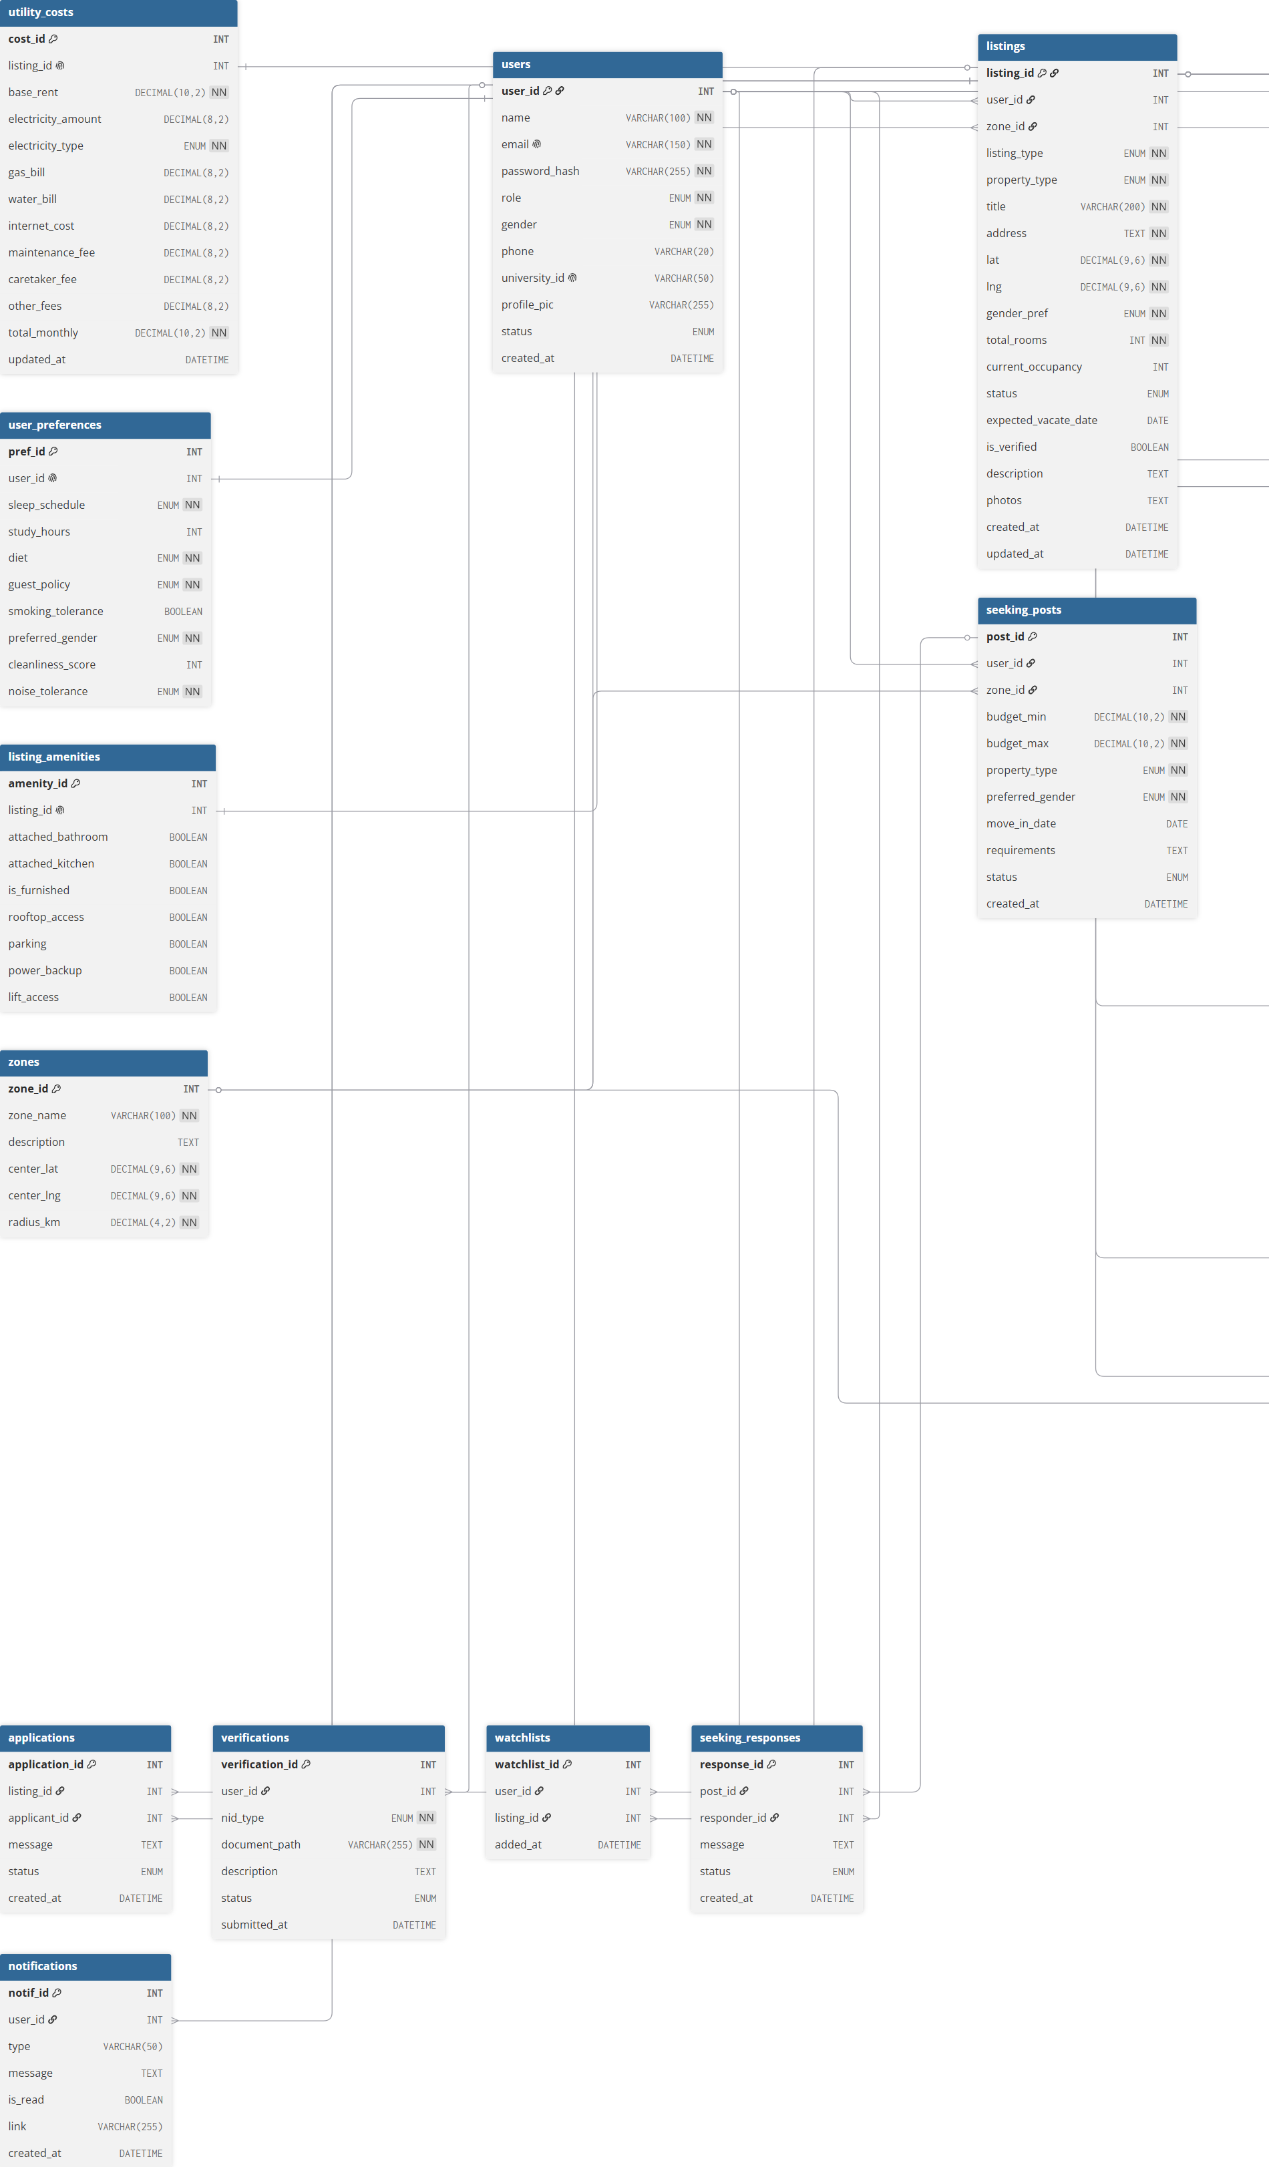
Figure: UIUNest Entity-Relationship Diagram (19 tables)

9. Database Schema - All 19 Tables
The following presents the full MySQL CREATE TABLE statements as implemented. All tables use InnoDB with referential integrity enforced via FOREIGN KEY constraints.

Table 1: users
CREATE TABLE users (
user_id INT AUTO_INCREMENT PRIMARY KEY,
name VARCHAR(100) NOT NULL,
email VARCHAR(150) UNIQUE NOT NULL,
password_hash VARCHAR(255) NOT NULL,
role ENUM('student','landlord','admin') NOT NULL,
gender ENUM('male','female','other') NOT NULL,
phone VARCHAR(20) NULL,
university_id VARCHAR(50) NULL,
profile_pic VARCHAR(255) NULL,
status ENUM('active','suspended') DEFAULT 'active',
created_at DATETIME DEFAULT CURRENT_TIMESTAMP
);

Table 2: zones
CREATE TABLE zones (
zone_id INT AUTO_INCREMENT PRIMARY KEY,
zone_name VARCHAR(100) NOT NULL,
description TEXT NULL,
center_lat DECIMAL(9,6) NOT NULL,
center_lng DECIMAL(9,6) NOT NULL,
radius_km DECIMAL(4,2) NOT NULL
);

Table 3: listings
CREATE TABLE listings (
listing_id INT AUTO_INCREMENT PRIMARY KEY,
user_id INT,
zone_id INT,
listing_type ENUM('full_property','peer_listing') NOT NULL,
property_type ENUM('single_room','shared_room','full_mess','sublet') NOT NULL,
title VARCHAR(200) NOT NULL,
address TEXT NOT NULL,
lat DECIMAL(9,6) NOT NULL,
lng DECIMAL(9,6) NOT NULL,
gender_pref ENUM('male','female','any') NOT NULL,
total_rooms INT NOT NULL,
current_occupancy INT DEFAULT 0,
status ENUM('available','occupied','soon_vacant') DEFAULT 'available',
expected_vacate_date DATE NULL,
is_verified BOOLEAN DEFAULT FALSE,
description TEXT NULL,
photos TEXT NULL,
created_at DATETIME DEFAULT CURRENT_TIMESTAMP,
updated_at DATETIME DEFAULT CURRENT_TIMESTAMP ON UPDATE CURRENT_TIMESTAMP,
FOREIGN KEY (user_id) REFERENCES users(user_id) ON DELETE CASCADE,
FOREIGN KEY (zone_id) REFERENCES zones(zone_id)
);

Table 4: utility_costs
CREATE TABLE utility_costs (
cost_id INT AUTO_INCREMENT PRIMARY KEY,
listing_id INT UNIQUE,
base_rent DECIMAL(10,2) NOT NULL,
electricity_amount DECIMAL(8,2) DEFAULT 0,
electricity_type ENUM('individual','shared') NOT NULL,
gas_bill DECIMAL(8,2) DEFAULT 0,
water_bill DECIMAL(8,2) DEFAULT 0,
internet_cost DECIMAL(8,2) DEFAULT 0,
maintenance_fee DECIMAL(8,2) DEFAULT 0,
caretaker_fee DECIMAL(8,2) DEFAULT 0,
other_fees DECIMAL(8,2) DEFAULT 0,
total_monthly DECIMAL(10,2) NOT NULL,
updated_at DATETIME DEFAULT CURRENT_TIMESTAMP ON UPDATE CURRENT_TIMESTAMP,
FOREIGN KEY (listing_id) REFERENCES listings(listing_id) ON DELETE CASCADE
);

Table 5: listing_amenities
CREATE TABLE listing_amenities (
amenity_id INT AUTO_INCREMENT PRIMARY KEY,
listing_id INT UNIQUE,
attached_bathroom BOOLEAN DEFAULT FALSE,
attached_kitchen BOOLEAN DEFAULT FALSE,
is_furnished BOOLEAN DEFAULT FALSE,
rooftop_access BOOLEAN DEFAULT FALSE,
parking BOOLEAN DEFAULT FALSE,
power_backup BOOLEAN DEFAULT FALSE,
lift_access BOOLEAN DEFAULT FALSE,
FOREIGN KEY (listing_id) REFERENCES listings(listing_id) ON DELETE CASCADE
);

Table 6: user_preferences
CREATE TABLE user_preferences (
pref_id INT AUTO_INCREMENT PRIMARY KEY,
user_id INT UNIQUE,
sleep_schedule ENUM('early','late','flexible') NOT NULL,
study_hours INT DEFAULT 0,
diet ENUM('vegetarian','non_veg','halal_strict') NOT NULL,
guest_policy ENUM('allowed','restricted','not_allowed') NOT NULL,
smoking_tolerance BOOLEAN DEFAULT FALSE,
preferred_gender ENUM('male','female','any') NOT NULL,
cleanliness_score INT CHECK (cleanliness_score BETWEEN 1 AND 5),
noise_tolerance ENUM('quiet','moderate','noisy') NOT NULL,
FOREIGN KEY (user_id) REFERENCES users(user_id) ON DELETE CASCADE
);

Table 7: reviews
CREATE TABLE reviews (
review_id INT AUTO_INCREMENT PRIMARY KEY,
listing_id INT,
reviewer_id INT,
value_for_money INT CHECK (value_for_money BETWEEN 1 AND 5),
listing_accuracy INT CHECK (listing_accuracy BETWEEN 1 AND 5),
landlord_response INT CHECK (landlord_response BETWEEN 1 AND 5),
cleanliness INT CHECK (cleanliness BETWEEN 1 AND 5),
safety INT CHECK (safety BETWEEN 1 AND 5),
composite_score DECIMAL(3,2) NOT NULL,
comment VARCHAR(500) NULL,
created_at DATETIME DEFAULT CURRENT_TIMESTAMP,
UNIQUE(listing_id, reviewer_id),
FOREIGN KEY (listing_id) REFERENCES listings(listing_id) ON DELETE CASCADE,
FOREIGN KEY (reviewer_id) REFERENCES users(user_id) ON DELETE CASCADE
);

Table 8: complaints
CREATE TABLE complaints (
complaint_id INT AUTO_INCREMENT PRIMARY KEY,
complainant_id INT,
against_user_id INT,
listing_id INT NULL,
category ENUM('hidden_costs','harassment',
'deposit_not_returned','misrepresentation','other') NOT NULL,
description TEXT NOT NULL,
status ENUM('submitted','under_review','resolved') DEFAULT 'submitted',
created_at DATETIME DEFAULT CURRENT_TIMESTAMP,
resolved_at DATETIME NULL,
FOREIGN KEY (complainant_id) REFERENCES users(user_id) ON DELETE CASCADE,
FOREIGN KEY (against_user_id) REFERENCES users(user_id) ON DELETE CASCADE,
FOREIGN KEY (listing_id) REFERENCES listings(listing_id) ON DELETE CASCADE
);

Table 9: seeking_posts
CREATE TABLE seeking_posts (
post_id INT AUTO_INCREMENT PRIMARY KEY,
user_id INT,
zone_id INT,
budget_min DECIMAL(10,2) NOT NULL,
budget_max DECIMAL(10,2) NOT NULL,
property_type ENUM('single_room','shared_room','full_mess','sublet','any') NOT NULL,
preferred_gender ENUM('male','female','any') NOT NULL,
move_in_date DATE NULL,
requirements TEXT NULL,
status ENUM('active','fulfilled') DEFAULT 'active',
created_at DATETIME DEFAULT CURRENT_TIMESTAMP,
FOREIGN KEY (user_id) REFERENCES users(user_id) ON DELETE CASCADE,
FOREIGN KEY (zone_id) REFERENCES zones(zone_id)
);

Table 10: monthly_bills
CREATE TABLE monthly_bills (
bill_id INT AUTO_INCREMENT PRIMARY KEY,
listing_id INT,
bill_month DATE NOT NULL,
electricity_amount DECIMAL(8,2) DEFAULT 0,
gas_amount DECIMAL(8,2) DEFAULT 0,
water_amount DECIMAL(8,2) DEFAULT 0,
internet_amount DECIMAL(8,2) DEFAULT 0,
other_amount DECIMAL(8,2) DEFAULT 0,
total_amount DECIMAL(10,2) NOT NULL,
per_person_amount DECIMAL(10,2) NOT NULL,
created_by INT,
created_at DATETIME DEFAULT CURRENT_TIMESTAMP,
FOREIGN KEY (listing_id) REFERENCES listings(listing_id) ON DELETE CASCADE,
FOREIGN KEY (created_by) REFERENCES users(user_id) ON DELETE CASCADE
);

Table 11: bill_payments
CREATE TABLE bill_payments (
payment_id INT AUTO_INCREMENT PRIMARY KEY,
bill_id INT,
resident_user_id INT NULL,
resident_label VARCHAR(50) NULL,
status ENUM('paid','unpaid') DEFAULT 'unpaid',
paid_at DATETIME NULL,
FOREIGN KEY (bill_id) REFERENCES monthly_bills(bill_id) ON DELETE CASCADE,
FOREIGN KEY (resident_user_id) REFERENCES users(user_id) ON DELETE CASCADE
);

Table 12: rent_history
CREATE TABLE rent_history (
history_id INT AUTO_INCREMENT PRIMARY KEY,
listing_id INT,
old_rent DECIMAL(10,2) NOT NULL,
new_rent DECIMAL(10,2) NOT NULL,
changed_at DATETIME DEFAULT CURRENT_TIMESTAMP,
changed_by INT,
FOREIGN KEY (listing_id) REFERENCES listings(listing_id) ON DELETE CASCADE,
FOREIGN KEY (changed_by) REFERENCES users(user_id) ON DELETE CASCADE
);

Table 13: items (UIUNest Exchange)
CREATE TABLE items (
item_id INT AUTO_INCREMENT PRIMARY KEY,
seller_id INT,
zone_id INT,
listing_id INT NULL,
category ENUM('furniture','appliances','electronics',
'kitchen','study','other') NOT NULL,
title VARCHAR(200) NOT NULL,
description TEXT NULL,
item_condition ENUM('new','like_new','good','fair') NOT NULL,
asking_price DECIMAL(10,2) NOT NULL,
reason_for_selling VARCHAR(300) NULL,
photo_url VARCHAR(255) NULL,
status ENUM('available','sold','withdrawn') DEFAULT 'available',
created_at DATETIME DEFAULT CURRENT_TIMESTAMP,
FOREIGN KEY (seller_id) REFERENCES users(user_id) ON DELETE CASCADE,
FOREIGN KEY (zone_id) REFERENCES zones(zone_id),
FOREIGN KEY (listing_id) REFERENCES listings(listing_id) ON DELETE SET NULL
);

Table 14: offers
CREATE TABLE offers (
offer_id INT AUTO_INCREMENT PRIMARY KEY,
item_id INT,
buyer_id INT,
offer_price DECIMAL(10,2) NOT NULL,
message VARCHAR(300) NULL,
status ENUM('pending','countered','accepted','rejected','withdrawn') DEFAULT 'pending',
counter_price DECIMAL(10,2) NULL,
created_at DATETIME DEFAULT CURRENT_TIMESTAMP,
updated_at DATETIME DEFAULT CURRENT_TIMESTAMP ON UPDATE CURRENT_TIMESTAMP,
FOREIGN KEY (item_id) REFERENCES items(item_id) ON DELETE CASCADE,
FOREIGN KEY (buyer_id) REFERENCES users(user_id) ON DELETE CASCADE
);

Table 15: applications
CREATE TABLE applications (
application_id INT AUTO_INCREMENT PRIMARY KEY,
listing_id INT,
applicant_id INT,
message TEXT NULL,
status ENUM('pending','accepted','rejected') DEFAULT 'pending',
created_at DATETIME DEFAULT CURRENT_TIMESTAMP,
FOREIGN KEY (listing_id) REFERENCES listings(listing_id) ON DELETE CASCADE,
FOREIGN KEY (applicant_id) REFERENCES users(user_id) ON DELETE CASCADE
);

Table 16: verifications
CREATE TABLE verifications (
verification_id INT AUTO_INCREMENT PRIMARY KEY,
user_id INT,
nid_type ENUM('National ID','Passport','Driving License') NOT NULL,
document_path VARCHAR(255) NOT NULL,
description TEXT NULL,
status ENUM('pending','approved','rejected') DEFAULT 'pending',
submitted_at DATETIME DEFAULT CURRENT_TIMESTAMP,
FOREIGN KEY (user_id) REFERENCES users(user_id) ON DELETE CASCADE
);

Table 17: watchlists
CREATE TABLE watchlists (
watchlist_id INT AUTO_INCREMENT PRIMARY KEY,
user_id INT,
listing_id INT,
added_at DATETIME DEFAULT CURRENT_TIMESTAMP,
UNIQUE(user_id, listing_id),
FOREIGN KEY (user_id) REFERENCES users(user_id) ON DELETE CASCADE,
FOREIGN KEY (listing_id) REFERENCES listings(listing_id) ON DELETE CASCADE
);

Table 18: seeking_responses
CREATE TABLE seeking_responses (
response_id INT AUTO_INCREMENT PRIMARY KEY,
post_id INT,
responder_id INT,
message TEXT NULL,
status ENUM('pending','accepted','rejected') DEFAULT 'pending',
created_at DATETIME DEFAULT CURRENT_TIMESTAMP,
FOREIGN KEY (post_id) REFERENCES seeking_posts(post_id) ON DELETE CASCADE,
FOREIGN KEY (responder_id) REFERENCES users(user_id) ON DELETE CASCADE
);

Table 19: notifications
CREATE TABLE notifications (
notif_id INT AUTO_INCREMENT PRIMARY KEY,
user_id INT,
type VARCHAR(50),
message TEXT,
is_read BOOLEAN DEFAULT FALSE,
link VARCHAR(255) NULL,
created_at DATETIME DEFAULT CURRENT_TIMESTAMP,
FOREIGN KEY (user_id) REFERENCES users(user_id) ON DELETE CASCADE
);

10. Key SQL Queries
This section presents the core SQL queries used by UIUNest, organized by DBMS operation type.

10.1 SELECT with Multi-Table JOIN
Fetching all listing data in one query joining 4 tables:
-- api/listings.php: Full listings query with owner, zone, and preferences
SELECT l.*,
z.zone_name AS zone,
u.name AS owner_name,
u.email AS owner_email,
up.sleep_schedule AS sleep,
up.diet,
up.guest_policy AS guest,
up.smoking_tolerance AS smoking,
up.noise_tolerance AS noise,
up.cleanliness_score AS cleanliness
FROM listings l
LEFT JOIN zones z ON l.zone_id = z.zone_id
LEFT JOIN users u ON l.user_id = u.user_id
LEFT JOIN user_preferences up ON l.user_id = up.user_id
WHERE l.listing_id = ?;
Fetching reviews joined with reviewer names:
-- api/listings.php: Reviews with reviewer name
SELECT r.*, u.name AS reviewer_name
FROM reviews r
LEFT JOIN users u ON r.reviewer_id = u.user_id
ORDER BY r.created_at DESC;
Exchange items with seller name and zone:
-- api/exchange.php: Items query
SELECT i.*, u.name AS seller, u.email AS seller_email, z.zone_name AS zone
FROM items i
LEFT JOIN users u ON i.seller_id = u.user_id
LEFT JOIN zones z ON i.zone_id = z.zone_id
ORDER BY i.created_at DESC;

10.2 SELECT with Aggregate Functions
Average rent per zone (used on Admin analytics dashboard):
-- api/admin_stats.php: Average rent by zone
SELECT z.zone_name AS zone,
COALESCE(AVG(uc.total_monthly), 0) AS avg_rent
FROM zones z
LEFT JOIN listings l ON z.zone_id = l.zone_id
LEFT JOIN utility_costs uc ON l.listing_id = uc.listing_id
GROUP BY z.zone_id, z.zone_name;
Composite review score calculation:
-- api/reviews.php: Compute composite score
SELECT listing_id,
AVG((value_for_money + listing_accuracy + landlord_response +
cleanliness + safety) / 5.0) AS composite_score,
COUNT(*) AS total_reviews
FROM reviews
WHERE listing_id = ?
GROUP BY listing_id;

10.3 SELECT with Subquery
Seeking vs listings demand gap per zone (correlated subquery):
-- api/admin_stats.php: Demand vs supply gap
SELECT
z.zone_name AS zone,
(SELECT COUNT(*) FROM seeking_posts sp
WHERE sp.zone_id = z.zone_id AND sp.status = 'active') AS seeking,
(SELECT COUNT(*) FROM listings l
WHERE l.zone_id = z.zone_id) AS listings
FROM zones z;
Check for duplicate active offer before INSERT:
-- api/offers.php: Prevent duplicate offer submission
SELECT offer_id FROM offers
WHERE item_id = ?
AND buyer_id = ?
AND status IN ('pending', 'countered', 'accepted');

10.4 INSERT Operations
User registration with bcrypt password:
-- api/register.php: Insert new user
INSERT INTO users (name, email, password_hash, role, gender, university_id)
VALUES (?, ?, ?, ?, ?, ?);
Listing creation with cost breakdown (two separate INSERTs in sequence):
-- api/listings.php: Create listing
INSERT INTO listings
(user_id, zone_id, listing_type, property_type, title, address,
lat, lng, gender_pref, total_rooms, description, photos)
VALUES (?, ?, ?, ?, ?, ?, ?, ?, ?, ?, ?, ?);
-- Then insert associated costs
INSERT INTO utility_costs
(listing_id, base_rent, electricity_amount, electricity_type,
gas_bill, water_bill, internet_cost, maintenance_fee,
caretaker_fee, other_fees, total_monthly)
VALUES (?, ?, ?, ?, ?, ?, ?, ?, ?, ?, ?);
Offer submission using atomic transaction:
-- api/offers.php: Insert offer with notification (atomic)
BEGIN TRANSACTION;
INSERT INTO offers (item_id, buyer_id, offer_price, message)
VALUES (?, ?, ?, ?);
INSERT INTO notifications (user_id, type, message, link)
VALUES (?, 'offer', ?, 'dashboard.html?tab=offers');
COMMIT;

10.5 UPDATE Operations
Updating listing status (Available / Occupied / Soon Vacant):
-- api/update_status.php: Change listing availability
UPDATE listings
SET status = ?, expected_vacate_date = ?, updated_at = NOW()
WHERE listing_id = ? AND user_id = ?;
Offer state machine - seller responds to an offer:
-- api/offers.php: Seller accepts, rejects, or counters
UPDATE offers
SET status = ?, counter_price = ?, updated_at = NOW()
WHERE offer_id = ?;
-- If accepted: mark item as sold
UPDATE items SET status = 'sold'
WHERE item_id = ?;
Rent history audit trail - archive old rent before updating:
-- api/listings.php: Rent update with history
INSERT INTO rent_history (listing_id, old_rent, new_rent, changed_by)
SELECT listing_id, base_rent, ?, ?
FROM utility_costs WHERE listing_id = ?;
UPDATE utility_costs
SET base_rent = ?, total_monthly = ?, updated_at = NOW()
WHERE listing_id = ?;

10.6 DELETE Operations
Admin suspending a user account (soft delete - status flag, not physical DELETE):
-- api/admin_action_user.php: Suspend user (soft delete)
UPDATE users SET status = 'suspended' WHERE user_id = ?;
Hard delete for exchange items (cascade deletes associated offers):
-- api/exchange.php: Delete item (ON DELETE CASCADE handles offers)
DELETE FROM items WHERE item_id = ? AND seller_id = ?;
Remove from watchlist:
-- api/watchlist.php: Toggle watchlist (DELETE if exists)
DELETE FROM watchlists WHERE user_id = ? AND listing_id = ?;

10.7 Notifications Query (User-Specific)
Fetching notifications for the currently logged-in user only:
-- api/notifications.php: Fetch user-specific notifications
SELECT * FROM notifications
WHERE user_id = ?
ORDER BY created_at DESC
LIMIT 50;
-- Mark all as read
UPDATE notifications SET is_read = TRUE WHERE user_id = ?;

11. Application Screenshots
The following screenshots show the current live version of UIUNest running locally on XAMPP.
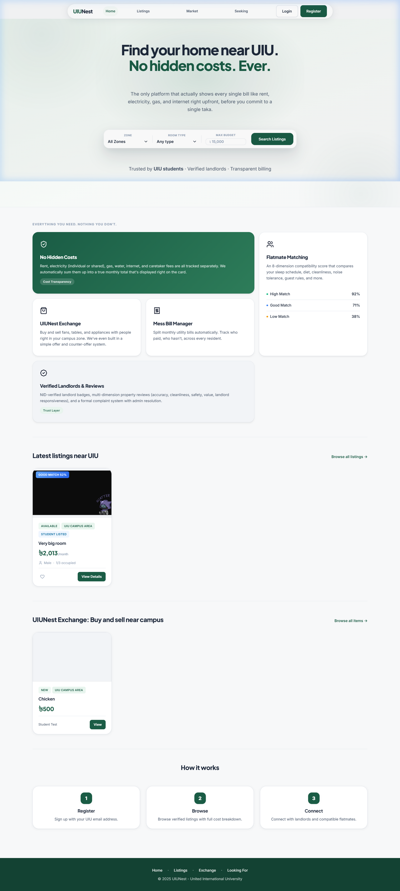
Figure: UIUNest Home Page - Hero section with navigation bar, stats, and featured zones
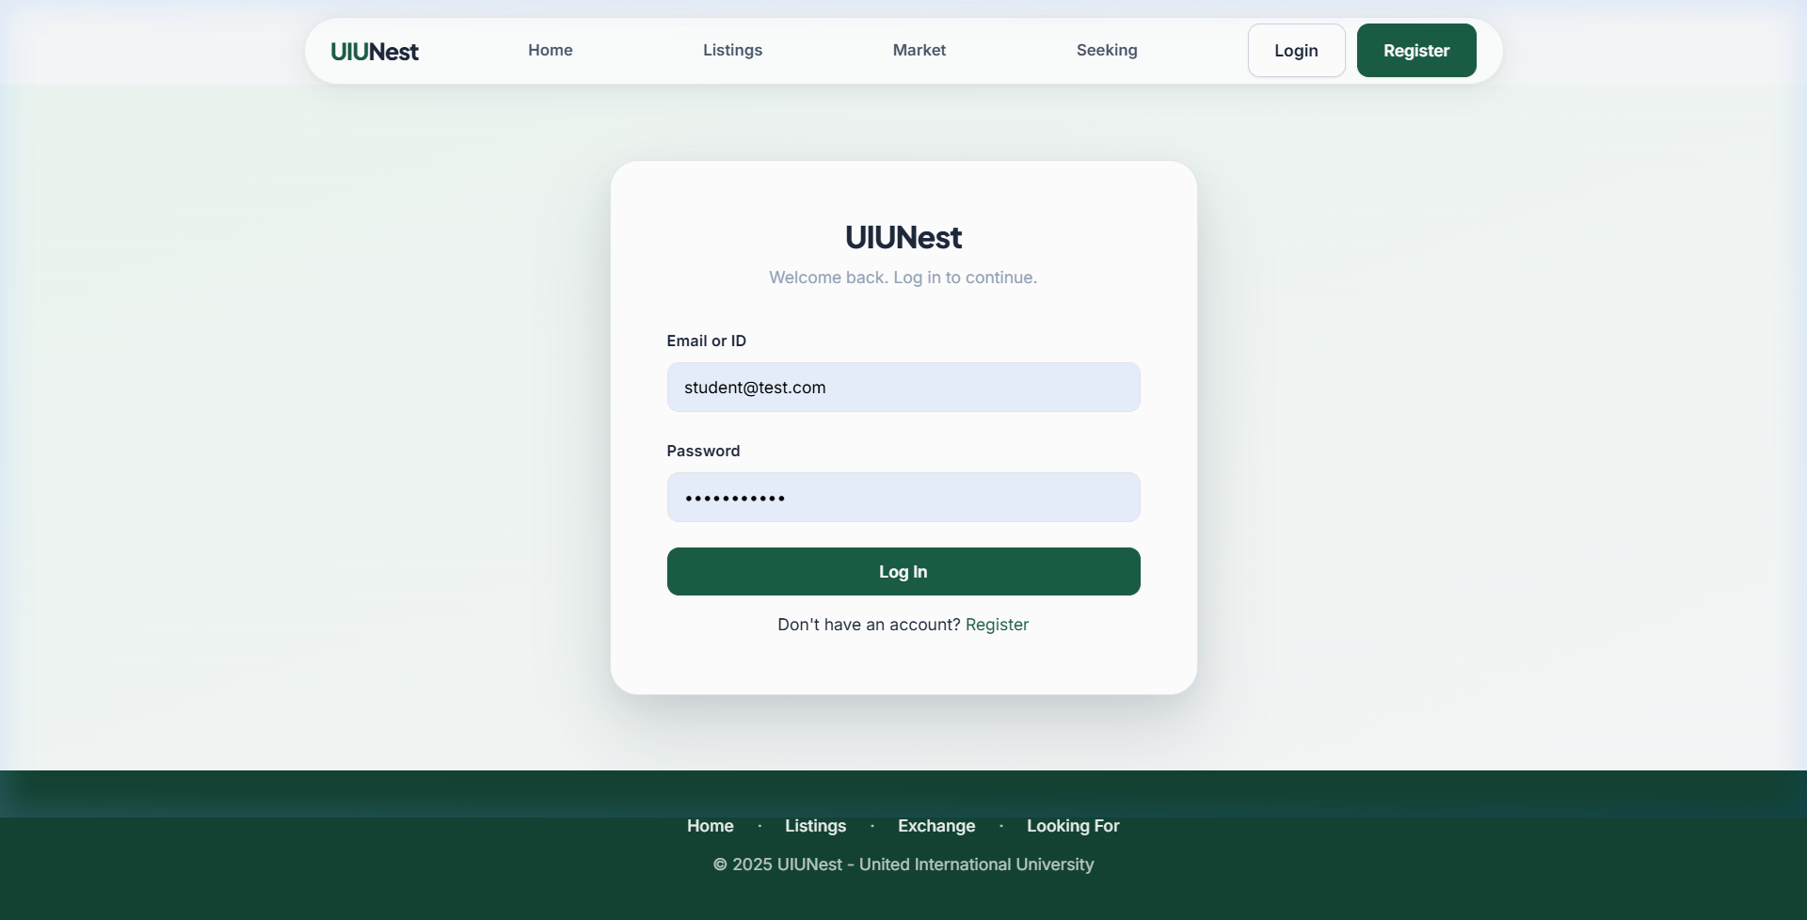
Figure: Login Page - Clean authentication form with emerald brand theme
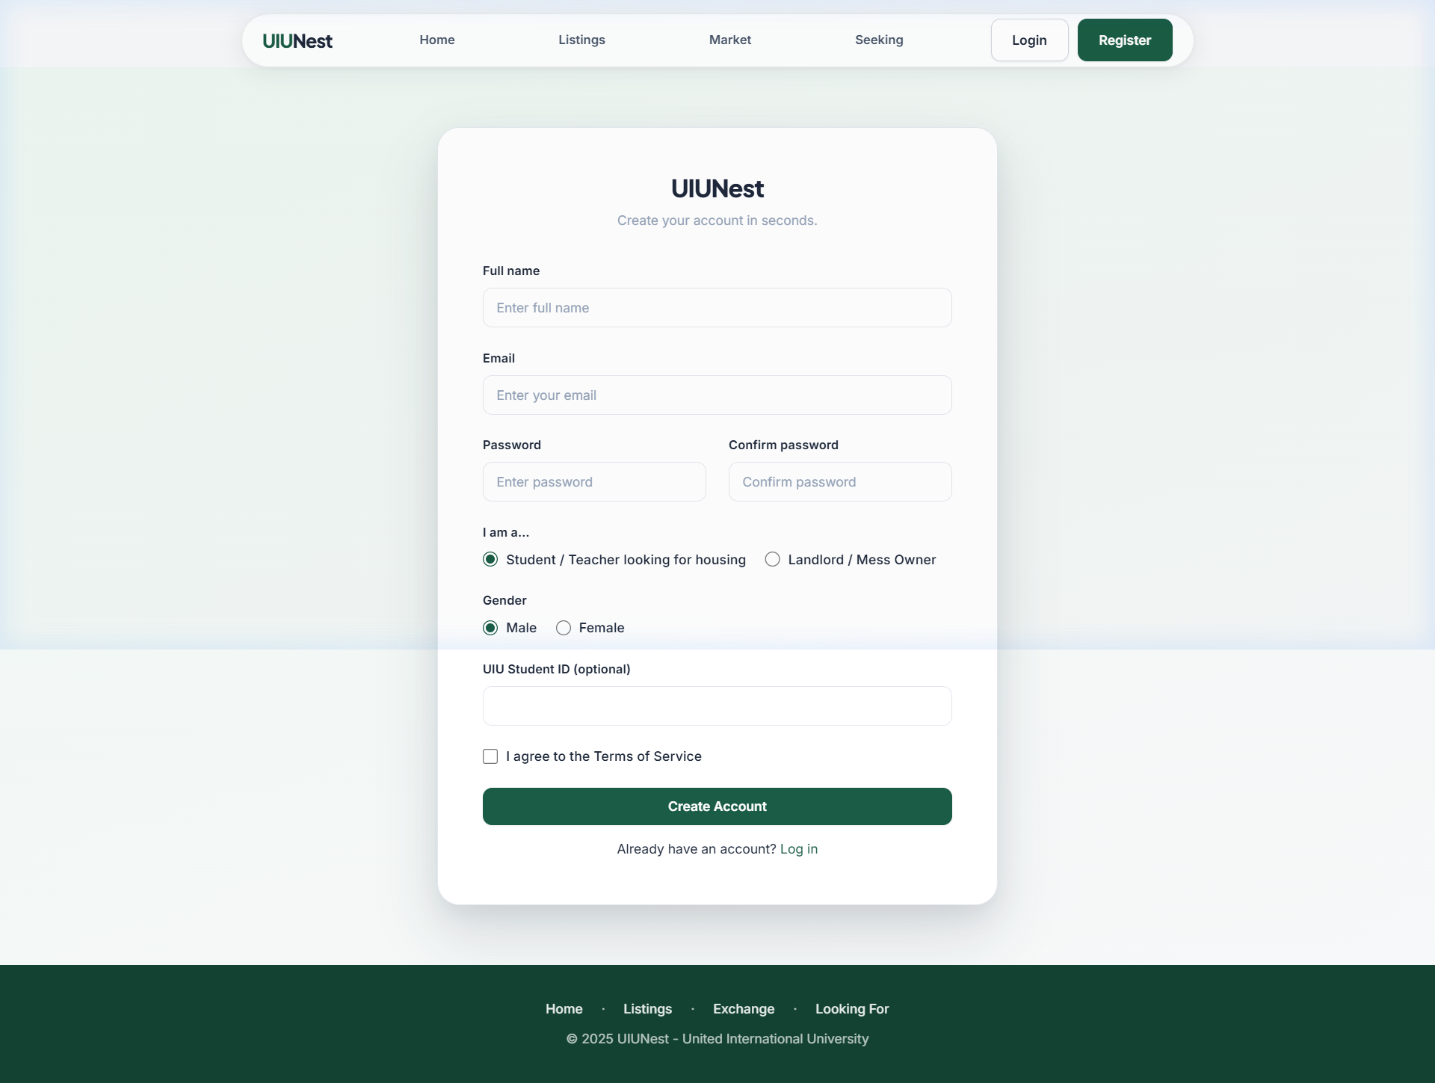
Figure: Registration Page - Role selection (Student/Landlord) with university ID field
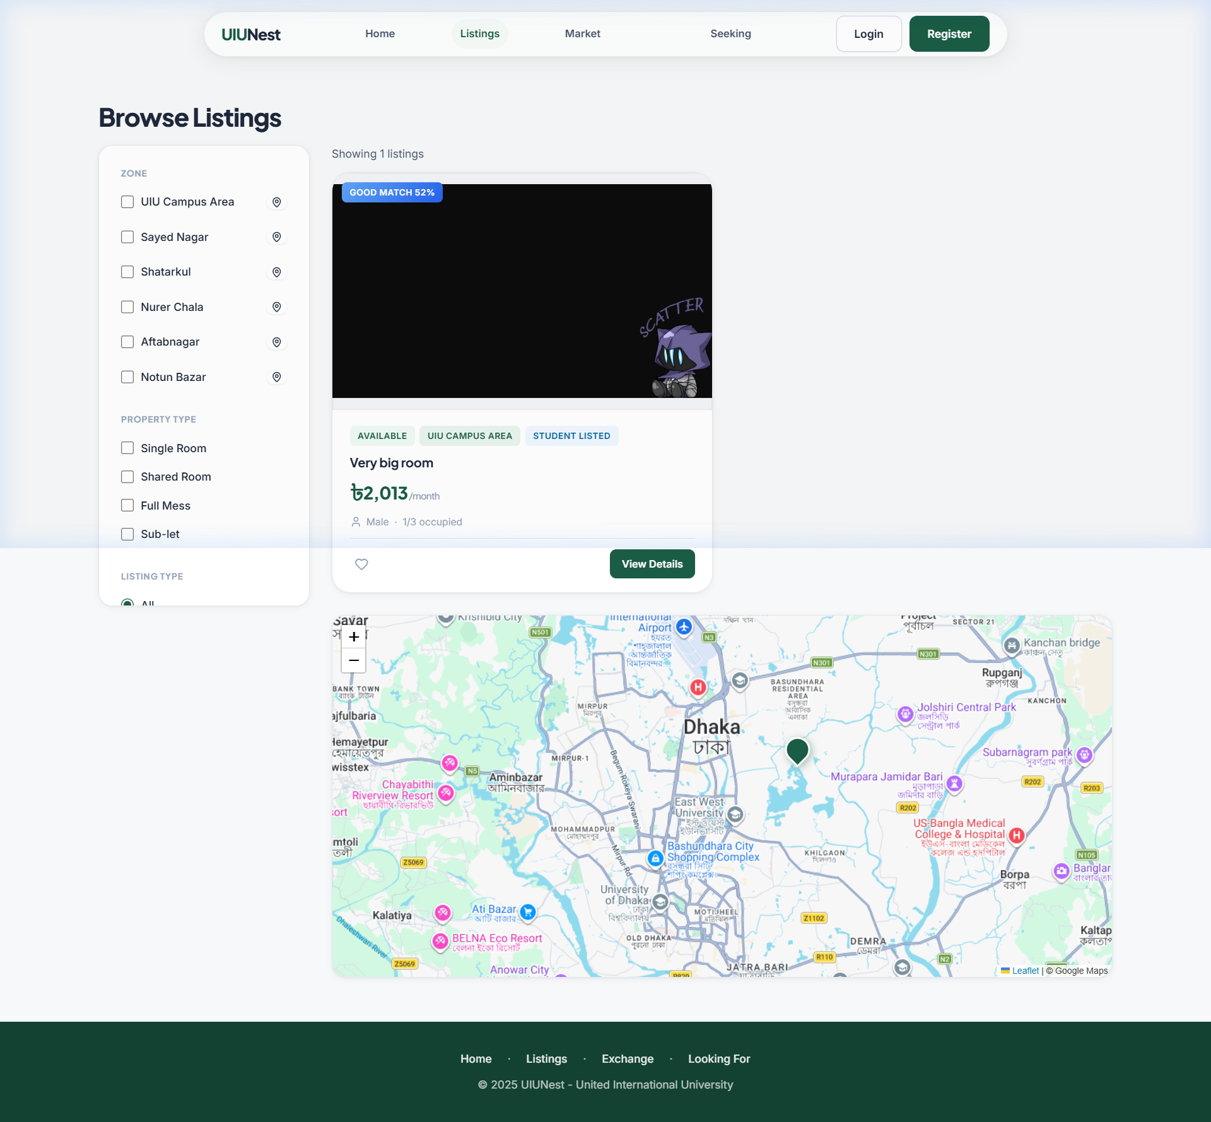
Figure: Listings Page - Filter sidebar, property cards with status badges, and interactive map
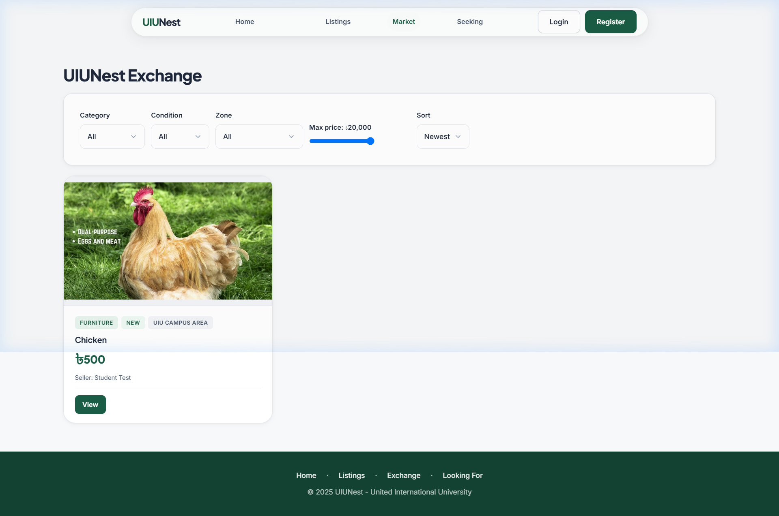
Figure: UIUNest Exchange Marketplace - Product grid with category and condition filters
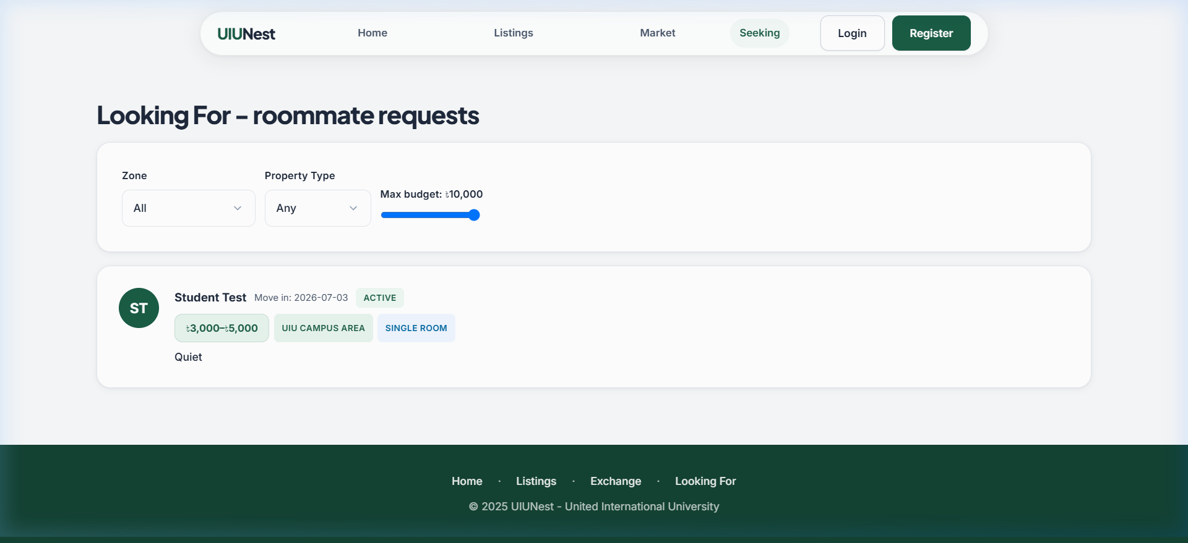
Figure: Seeking Board - Student housing request cards with zone and budget information

12. User Roles & Access Control
UIUNest implements role-based access control (RBAC) through a single users table differentiated by a role ENUM field. Each role has distinct permissions enforced at both the UI and API layer.
Feature / Action | Student | Landlord | Admin
Register & login | ✓ | ✓ | ✓
View listings | ✓ | ✓ | ✓
Apply for a listing | ✓ | ✗ | ✗
Create full property listing | ✗ | ✓ | ✗
Create peer listing (spare seat) | ✓ | ✗ | ✗
Submit verification document | ✗ | ✓ | ✗
Sell item on Exchange | ✓ (if verified) | ✓ (if verified) | ✗
Submit offer on Exchange | ✓ | ✓ | ✗
Submit a review | ✓ | ✗ | ✗
File a complaint | ✓ | ✓ | ✗
Manage mess bills | ✓ (own mess) | ✓ (own mess) | ✗
Approve verifications | ✗ | ✗ | ✓
Resolve complaints | ✗ | ✗ | ✓
Suspend users | ✗ | ✗ | ✓
View admin analytics | ✗ | ✗ | ✓
Access admin panel | ✗ | ✗ | ✓

13. System Architecture
UIUNest follows a classic three-tier web application architecture:

Presentation Layer (Frontend)
HTML/CSS/JS pages served as static files by Apache. No server-side rendering - all dynamic content is loaded via JavaScript fetch() calls to API endpoints. The design system is defined in style.css using CSS custom properties. Shared utilities (authentication helpers, rendering functions, toast notifications, watchlist management) are in app.js which is included on every page.

Application Layer (PHP API)
RESTful API endpoints in the /api/ directory. Each file handles one resource (listings.php, exchange.php, offers.php, etc.). All endpoints use PDO prepared statements for SQL injection prevention. Session state (session_start()) identifies the current user. Role checks are enforced at the API level - a student cannot call admin endpoints even by URL manipulation.

Data Layer (MySQL)
MySQL 8 database with 19 tables organized into functional layers. Foreign key constraints with ON DELETE CASCADE ensure referential integrity. UNIQUE constraints prevent duplicate reviews, duplicate watchlist entries, and duplicate active offers. All monetary values use DECIMAL(10,2) - never FLOAT - to avoid rounding errors.

Request Flow Example: Submitting an Offer
Browser (JavaScript)
└─► fetch('api/offers.php', { method: 'POST', body: JSON.stringify({itemId, offerPrice, message}) })
│
▼
PHP (api/offers.php)
├─► session_start() → validate user is logged in
├─► Check for existing active offer (SELECT query)
├─► BEGIN TRANSACTION
│ ├─► INSERT INTO offers (item_id, buyer_id, offer_price, message)
│ └─► INSERT INTO notifications (user_id=seller, type='offer', message, link)
└─► COMMIT → return { success: true }
│
▼
Browser
└─► Show success toast → update UI state

14. Limitations
• No real-time messaging: The current platform uses a request-response model. There is no WebSocket or real-time push system - users must refresh to see new notifications and offers. A future version could use Server-Sent Events or WebSockets.
• File storage is local: Uploaded photos are stored on the local server filesystem (/uploads/). In a production deployment, these would need to be moved to a cloud storage service (e.g., AWS S3, Cloudflare R2) to support horizontal scaling.
• Compatibility matching is client-side: The compatibility score is computed in JavaScript on the frontend (app.js) rather than in an SQL query. This means it cannot be used as a sort criterion for server-side queries. A production version would implement this as a stored function or computed column.
• No email/SMS integration: Notifications exist only inside the platform. There is no email or SMS system for critical alerts (new offer, application accepted). Users must log in to see notifications.
• Map is for display only: The Leaflet map shows listing pins but does not allow drawing a search radius or filtering by map viewport. Zone-based filtering is the primary geographic filter.
• No payment gateway: UIUNest tracks bill payment status (paid/unpaid) but has no integration with a payment gateway (bKash, Nagad, or card). All payments are assumed to be recorded manually by the mess manager.
• Verification uses document metadata only: The prototype stores document type and description for verification. A production system would require actual ID document upload and an admin review workflow with document image viewing.

15. Future Work
• Mobile Application: A native Android/iOS app using the existing PHP API as backend, providing push notifications for offers, applications, and availability changes.
• Real-Time Notifications: WebSocket integration (e.g., Ratchet PHP or Node.js bridge) for instant offer and application notifications without page refresh.
• Advanced Compatibility Matching: Move the compatibility scoring algorithm from JavaScript to a MySQL stored procedure, enabling server-side sorting and filtering by compatibility score.
• Expansion to Other Universities: The zone system is already designed for multi-campus support. Adding more universities requires only a new set of zones and allowing university-specific domain email registration.
• AI-Powered Listing Recommendations: A recommendation engine using collaborative filtering (users who liked X also viewed Y) built on top of the existing watchlist and view history data.
• Payment Integration: Integration with bKash or Nagad APIs to allow mess members to pay their monthly bill share directly through the platform, with automatic status update in bill_payments.
• Neighborhood Rating System: The neighborhood_ratings table is designed in the schema but not yet implemented. Adding the ability for users to rate zones on safety, transport, and noise would add another data layer to the platform.
• Moderation AI: Using a content moderation API (e.g., Google Perspective API) to automatically flag offensive content in complaints and review text before admin review.

16. Conclusion
UIUNest was built to solve a real problem that every UIU student living near campus has faced: finding housing through an informal, fragmented, and often dishonest process. The platform replaces that process with a structured, transparent, and accountable system.
From a database systems perspective, UIUNest demonstrates the full breadth of relational database concepts covered in the DBMS laboratory course:
• SELECT with multi-table LEFT JOINs across up to 4 tables in a single query
• INSERT operations including atomic multi-table inserts using PDO transactions
• UPDATE operations including the audit trail pattern (rent_history) and state machine transitions (offer status)
• DELETE with ON DELETE CASCADE for referential integrity
• Aggregate functions: AVG(), COUNT(), SUM(), COALESCE() for analytics
• Correlated subqueries for demand gap analysis
• UNIQUE constraints enforced at the database level for business rules
• Foreign key constraints across all 19 tables with appropriate cascade/set-null behaviors
The system was built with a production-grade mindset: all SQL uses prepared statements, passwords are bcrypt-hashed, sessions are validated at every API endpoint, and critical operations (offer submission, bill entry) use atomic transactions to prevent partial state.
UIUNest demonstrates that a DBMS-driven application can solve real, everyday problems for a university community - while simultaneously serving as a comprehensive exercise in relational database design, normalization, and SQL query engineering.

